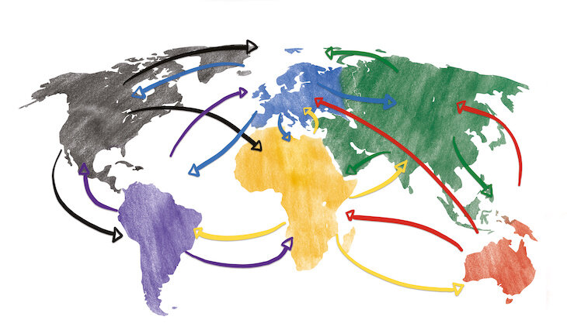

Year 6 Curriculum Newsletter: Spring 2 2026
Computing
The children will be taught a series of lessons from the Sheffield Computing Scheme. This will build on their prior knowledge and skills.
RE
Our focus religion this half term is Christianity, and the children will be exploring the question -" Why do some people believe in god and some people not?"
Personal development
The next topic in our PSHE curriculum is ‘Healthy Me’. The children will learn how to keep themselves healthy and safe by discussing a range of topics such as: diet, drugs and exercise. In our online safety lessons children will explore the issue of online bullying.

Science
In Science this half term, we will be learning about ‘light’. Within this, the objectives we will cover are: to recognise that light appears to travel in straight lines, use the idea that light travels in straight lines to explain that objects are seen because they give out or reflect light into the eye, explain that we see things because light travels from the light sources to our eyes and lastly to explain why shadows have the same shape.
Topic: Geography - Globalisation
In geography this half term, we will learn about: economic activity including trade links, and the distribution of natural resources including energy, food, minerals and water across the globe. We will focus on where our clothes and food originate from.
Maths
This half term the children will learn about: angles, geometry, statistics (including graphs) and ratio. We will also continue our daily arithmetic sessions to build speed in this area of maths.
DT
In DT the children will be designing and creating their own phone case. They will learn a range of sewing skills and understand the importance of measuring accurately. As part of the process, we will discuss the planning and evaluation process.

English
In English this term the children will be looking at Greek Myths focusing on Theseus and the Minitour. The children will create their own narrative and hero based on this myth. Within this topic, children will learn how to punctuate speech correctly, use multi clause sentences and use appropriate technical vocabulary.
Globalisation
PE: Tuesday and Thursday

