WEEKLY REMINDERS
THE WEEK AHEAD W/C 10th Feb 2025
Meal week
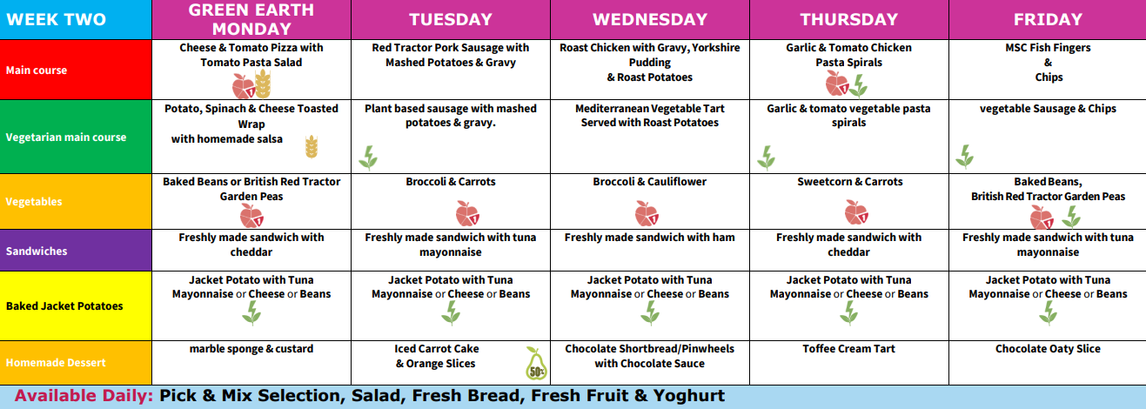
PLEASE NOTE ALL MEALS MARKED WITH A VG ARE VEGAN
Tuesday 11th Feb | Year 5TW – Swimming, please ensure that the children have their Swim kits
Thursday 13th Feb | Year 2 will be visiting a Mosque during the morning session.
Friday 14th Feb | End of term, we hope you all have a lovely break and look forward to seeing you refreshed on Tuesday 25th February
IMPORTANT INFORMATION
 |  | Information
Please note that all children in Years 1 and 2 should be taken to the door with a parent. Thank you

The Carfield Friends quiz is back!

Friday 28 February, 7.30-10pm in the Lower Hall.

Get together a team of 4-6 and then book your tickets at http://www.pta-events.co.uk/carfieldfriends

Food platters can be pre-ordered (same link as above) and there’ll be a full bar to buy drinks.

If you’d like to help with the bar, more volunteers are needed. No bar experience necessary! Please email carfieldfriends@outlook.com

Carfield Friends will also be holding a bottle raffle on the night. If you have any new, giftable bottles to donate (booze, bubble bath, fancy oil - whatever you like!) please take them to the office.

Thank you!
Carfield Friends

-----------------------------------------------------------------------------------

Virtual School Rotherham are excited to announce a programme of Sensory Workshops. These online Sensory Workshops will be facilitated by an Occupational Therapist, Sadie Charlton.

The sessions are FREE OF CHARGE on each of the below dates via Microsoft Teams, these will be at10:30 - 11:30 and 18:00 - 19:00 for Parent and Carers. Each session will last approximately 1 hour.

The sessions will take place on the following dates and will explore the areas listed.

Wed 12th Feb 2025 - Interoception: What's going on inside
Wed 19th Mar 2025 - Sensory & Emotional Regulation
Wed 23rd April 2025 - Creating Sensory Diets & Routines
Wed 14th May 2025 - Designing Sensory Friendly Environments
Wed 11th June 2025 - Supporting Transition Through A Sensory Lens
Wed 2nd July 2025 - School Readiness (Early Years Special)

Please note, they are unable to offer specific advice or intervention to individual children and this session is for information/learning purposes only.

To register your interest in attending please complete and submit the form below. Teams meeting link and full joining instructions will be forwarded to the email address you provide on the form.
VSR - Sensory Workshops 2024/2025 - Foster Carer/Parent and School staff sessions (office.com)

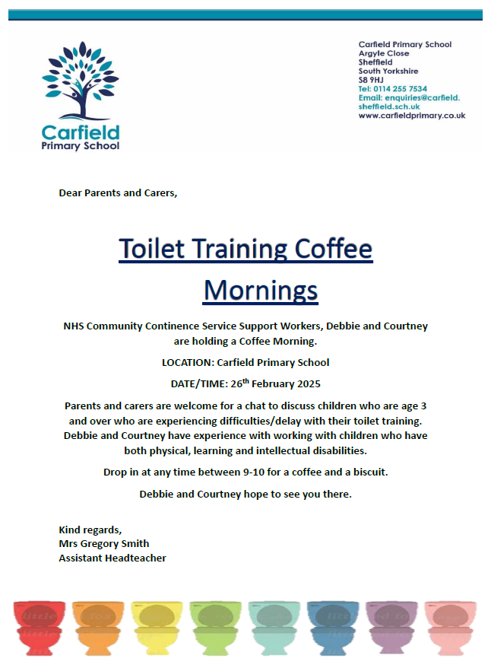

" Next Level Football Academy have an exclusive offer for you this February Half Term!
Running Monday - Friday, 9am-15:30pm at Goals Sheffield players will get to work on all aspect of football development from strength & conditioning to learning to score like Harry Kane!
The price of the camp is usually £100 for 5 days of football! However, we have an exclusive offer of just £80 for all 5 days! This is a limited time offer so be sure to secure your space today, please message Nathan on WhatsApp through the link below to secure your space on the camp!
Drop off is from 8:30am and lunch is not included.
Click here: LINK TO BOOK! "

Could your child be entitled to Free School Meals?
To check your eligibility for FSM please go to the government website and complete the application. https://www.gov.uk/apply-free-school-meals or contact the school office enquiries@carfield.sheffield.sch.uk. More information can also be found or web site www.carfieldprimary.co.uk.

Weekly Attendance
Attendance for the week commencing 3rd February

Whole school 94.65%

REMINDERS
Activity | Information | Deadline
CROSS COUNTRY  PE | Saturday 1st March Graves Park 10am start (Championships)  Saturday 15th March Castle Dyke 9:30am start (Relays)  PE Days:  Please ensure your child comes to school in their PE uniform on their allocated day with suitable footwear  Monday Y2 and Y6  Tuesday Y3 and Y1  Wednesday Y4 and Y5 | Weekly
ONLINE SAFETY
FOCUS FOR THE WEEK:
WhatsApp
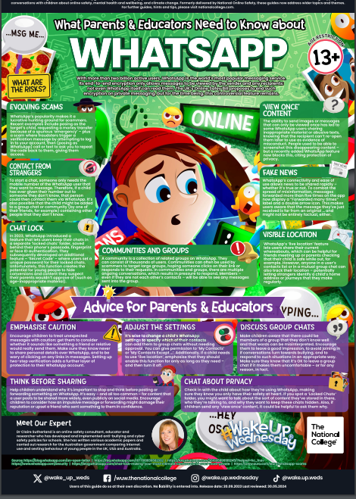

(More leaflets and guidance can be found on our web page: https://www.carfieldprimary.co.uk/online-safety/

School Policies
Absence  If your child is not well enough to attend school, you must inform school every day they are absent. You can do this by calling school on 0114 2557534, and pressing 1 to leave us a voicemail message. Please provide  - your child’s full name  - your child’s class  - a brief explanation of the reason for absence. | Medicine In School  Please may we remind you that if your child requires any prescribed medicine by the doctor during school hours, this must be handed in at the school office with a completed parental agreement to administer medicine form. Medicine should be in its original packaging; we cannot accept individual tablets or sachets that are not in the original box. No medicine should be left with a child or in a school bag at any time. We are unable to administer any medicine without a completed parental agreement form.
Community Events
SCC Newsletter https://content.govdelivery.com/accounts/UKSHEFFIELD/bulletins/3be9d0a
welcometosheffiled.co.uk/visit/what-s-on/familyevents/ visit this web site for lots of things to do in Sheffield for family’s and children.
https://www.eventbrite.co.uk/poi/united-kingdom--sheffield/meersbrook-park--09Hd3/

