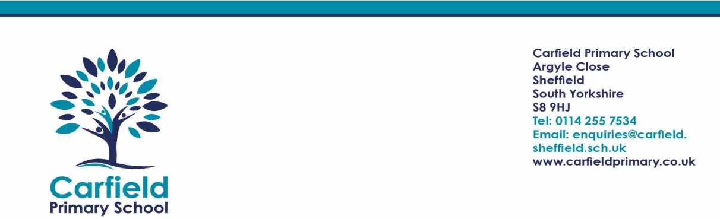

Dear Parents and Carers,

Toilet Training Coffee Mornings
NHS Community Continence Service Support Workers, Debbie and Courtney are holding a Coffee Morning.
LOCATION: Carfield Primary School
DATE/TIME: 16th October
Parents and carers are welcome for a chat to discuss children who are age 3 and over who are experiencing difficulties/delay with their toilet training. Debbie and Courtney have experience with working with children who have both physical, learning and intellectual disabilities.
Drop in at any time between 9-10 for a coffee and a biscuit.
Debbie and Courtney hope to see you there.

Kind regards,
Mrs Gregory Smith
Assistant Headteacher



