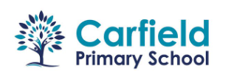

Sports Premium allocated funds for Carfield Primary 2024

Funds received £20,780