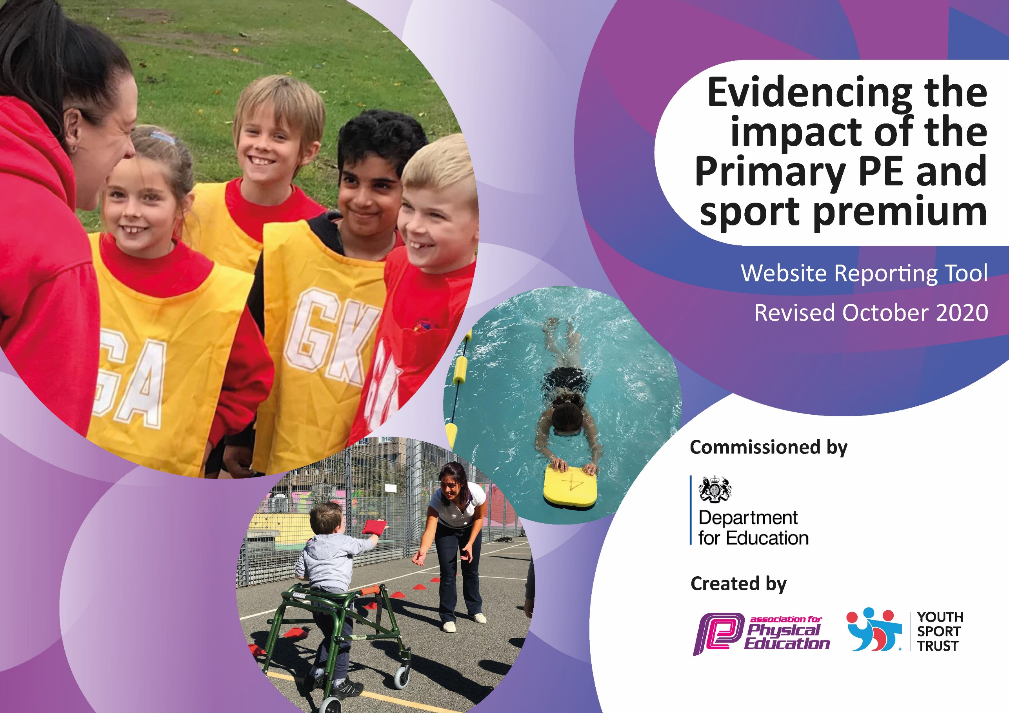

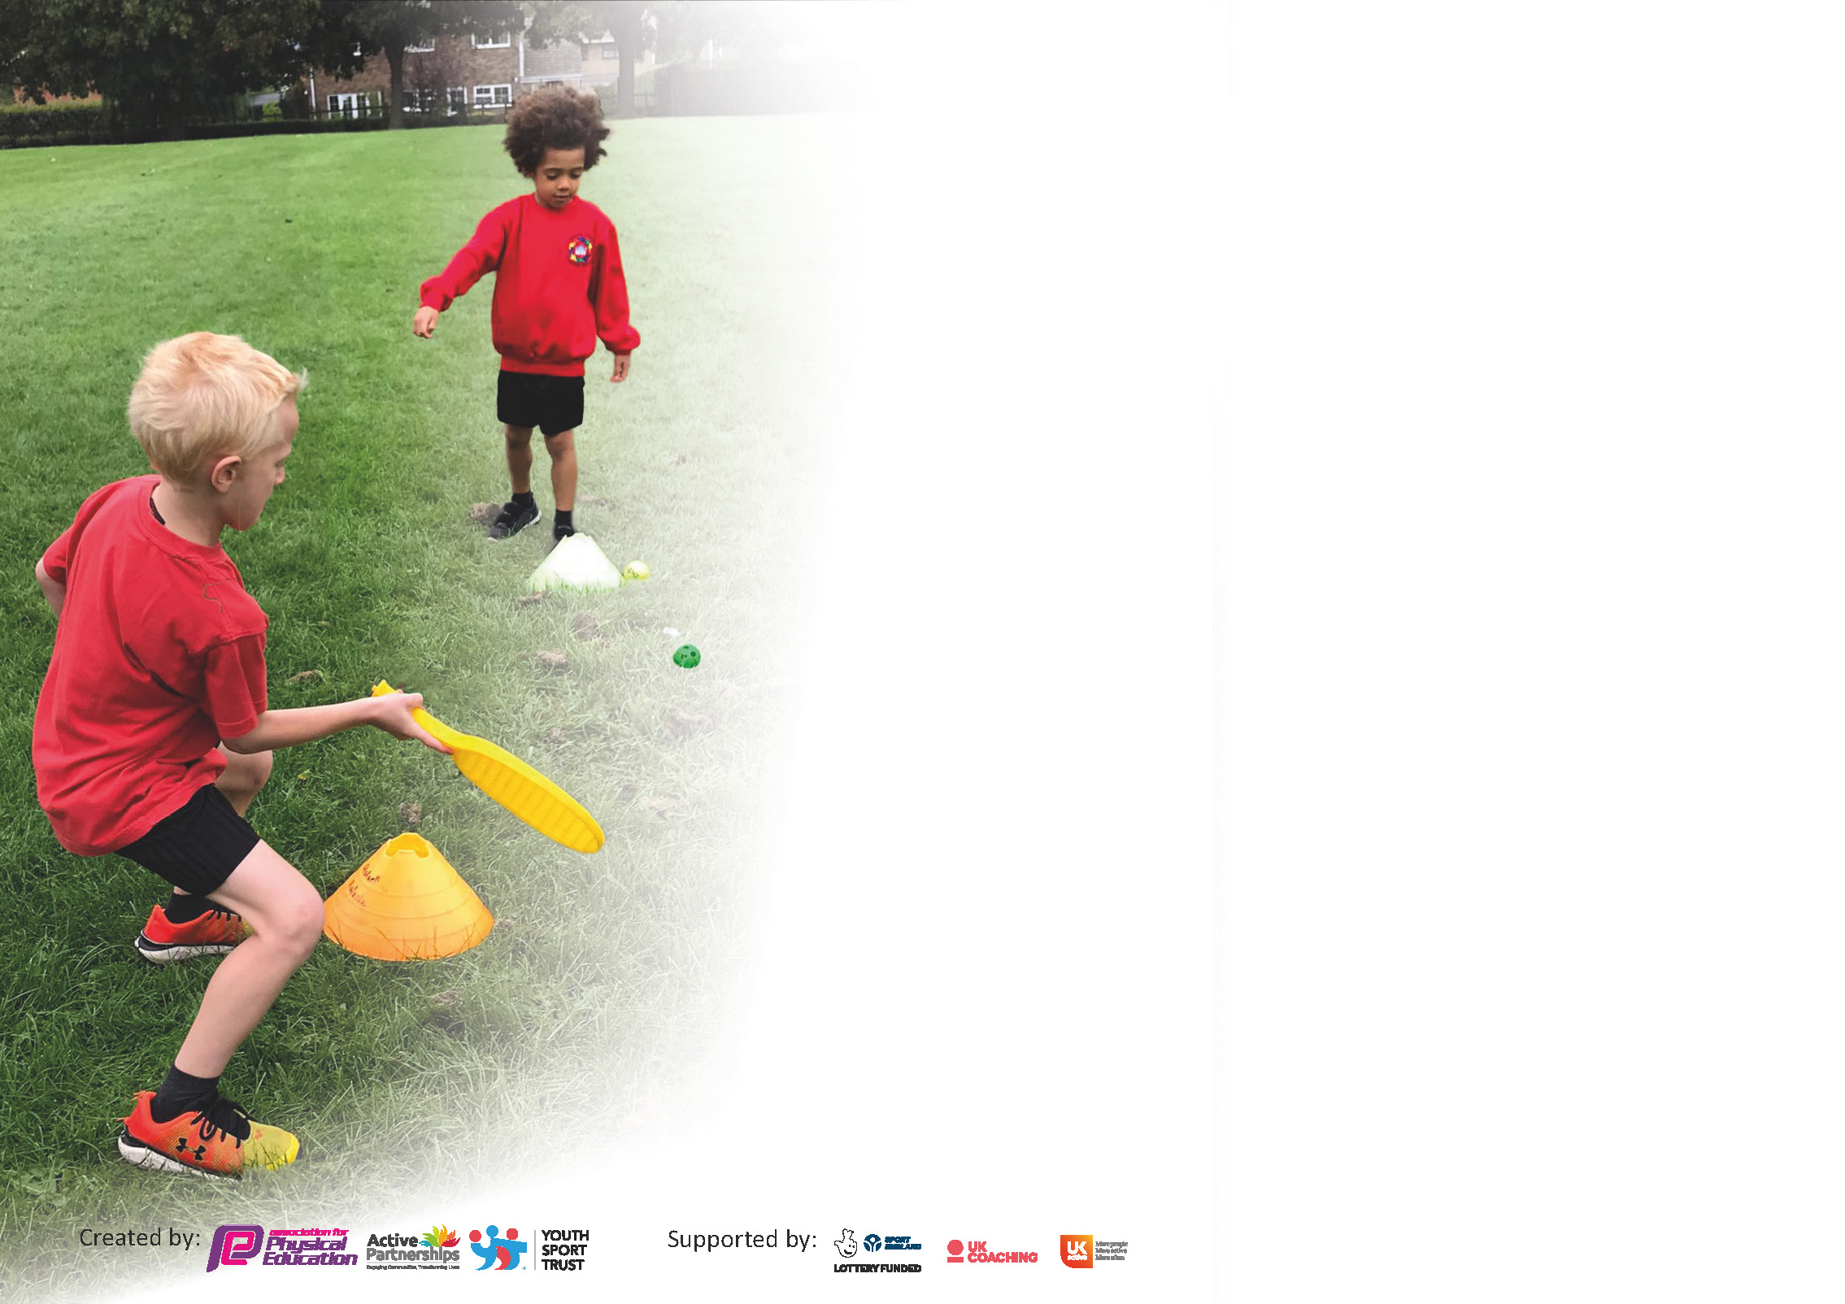

It is important that your grant is used effectively and based on school need. The Education InspectionFramework(Ofsted 2019 p64) makes clear there will be a focus on **‘whether leaders and those responsible for governors all understand their respective roles and perform these in a way that enhances the effectiveness of the school’**.

Under the Quality of Education criteria(p41) inspectors consider the extent to which schools can articulate their curriculum (INTENT), construct their curriculum (IMPLEMENTATION) and demonstrate the outcomes which result (IMPACT).

Toassistschoolswithcommontransferablelanguagethistemplatehasbeendevelopedtoutilisethe samethreeheadingswhichshouldmakeyourplanseasilytransferablebetweenworkingdocuments.

Schools must use the funding to make **additional and sustainable** improvements to the quality of PhysicalEducation,SchoolSportandPhysicalActivity (PESSPA)theyoffer.Thismeansthatyoushoulduse

the Primary PE and sport premium to:

* Develop or add to the PESSPA activities that your school alreadyoffer
* Build capacity and capability within the school to ensure that improvements made nowwill benefit pupils joining the school in futureyears

Please visit gov.ukfor the revised DfE guidance including the 5 key indicators across which schools should demonstrate an improvement. This document will help you to review your

provision and to report your spend. DfE encourages schools to use this template as an effective way of meeting the reporting requirements of the Primary PE and sport premium.

We recommend you start by reflecting on the impact of current provision and reviewing the previous spend.

Schools are required to publish detailsof how they spend this funding as well as on the impact it has on pupils’ PE and sport participation and attainment by the end of the summer term or by **31st July 2021** at the latest.

# ** In the case of any under-spend from 2019/20 which has been carried over this must be used and published by 31st March 2021.

We recommend regularly updating the table and publishing it on your website throughout the year. This evidences your ongoing self-evaluation of how you are using the funding to secure maximum, sustainable impact. Final copy must

be posted on your website by the end of the academic year and no later than the 31st July 2021. To see an example of how to complete the table please click HERE.

Createdby: Supported by:

Please note: Although there has been considerable disruption in 2020 it is important that you publish details on your website of how you spend the funding - this is a legal requirement.

Support for review and reflection - considering the 5 key indicators from DfE, what development needs are a priority for your setting and your pupils now and why? Use the space below to reflect on previous spend and key achievements and areas for development.

N.B. In this section you should refer to any adjustments you might have made due to Covid-19 and how these will influence further improvement.

|  |  |
| --- | --- |
| Key achievements to date until July 2020: | Areas for further improvement and baseline evidence of need: |
| * The school maintaining gold mark status * Good take-up for range of lunchtime and after school clubs * CPD provided for staff and lessons delivered by qualified coaches * Improved resourcing for PE lessons and lunchtime activities | * Continue to improve tracking of vulnerable groups to ensure increased participation in clubs and competition. * Continue to provide catch-up swimming sessions for Year 5 pupils to ensure a higher percentage of Year 6 children leave Carfield being able to swim 25m (in 2020-21, there needs to be catch up sessions for Year 4 cohort who missed swimming lessons in 2019-20). * Take part in virtual sporting events |

Did you carry forward an underspend from 2019-20 academic year into the current academic year? YES

# If YES you must complete the following section

**If NO, the following section is not applicable to you**

If any funding from the academic year 2019/20 has been carried over you MUST complete the following section. Any carried over funding MUST be spent by 31 March 2021.

|  |  |  |  |  |
| --- | --- | --- | --- | --- |
| **Academic Year: September 2020 to March 2021** | **Total fund carried over:**  **£10, 181** | **Date Updated: November 2020** |  | |
| What Key indicator(s) are you going to focus on?  **Key indicator 2:** The profile of PESSPA being raised across the school as a tool for whole school improvement | | | | Total Carry Over Funding: |
| £ 11, 873.88 |
| **Intent** | **Implementation** | | **Impact** |  |
| Your school focus should be clear how you want to impact on your pupils. | Make sure your actions to achieve are linked to your intentions: | Carry over funding allocated: | Evidence of impact: How can you measure the impact on your pupils; you may have focussed on the difference that PE, SS &PA have made to pupils re-engagement with school. What has changed?: | Sustainability and suggested next steps and how does this link with the key indicators on which you are focussing this academic year?: |

|  |  |
| --- | --- |
| Meeting national curriculum requirements for swimming and water safety.  N.B Complete this section to your best ability. For example you might have practised safe self-rescue techniques on dry land. | £2,627 |
| What percentage of your current Year 6 cohort swim competently, confidently and proficiently over a distance of at least 25 metres?  **N.B.** Even though your pupils may swim in another year please report on their attainment on leaving primary school at the end of the summer term 2020. | 85% |
| What percentage of your current Year 6 cohort use a range of strokes effectively [for example, front crawl, backstroke and breaststroke]? | 85% |
| What percentage of your current Year 6 cohort perform safe self-rescue in different water-based situations? | 100% |
| Schools can choose to use the Primary PE and sport premium to provide additional provision for swimming but this must be for activity **over and above** the national curriculum requirements. Have you used it in this way? | Yes – the current Y5 (15 children from 2 classes) cohort who could not swim will go again for booster classes once the class that missed the sessions due to lockdown have completed their lessons. |

**Action Plan and Budget Tracking**

Capture your intended annual spend against the 5 key indicators. Clarify the success criteria and evidence of impact that you intend to measure to evaluate for pupils today and for the future.

|  |  |  |  |  |
| --- | --- | --- | --- | --- |
| **Academic Year:** 2020/21 | **Total fund allocated:** £20,917 | **Date Updated: November 2020** | |  |
| **Key indicator 1:** The engagement of all pupils in regular physical activity – Chief Medical Officers guidelines recommend that primary school pupils undertake at least 30 minutes of physical activity a day in school | | | | Percentage of total allocation: |
| % |
| **Intent** | **Implementation** | | **Impact** |  |
| Your school focus should be clear what you want the pupils to know and be able to do and about  what they need to learn and to  consolidate through practice: | Make sure your actions to achieve are linked to your intentions: | Funding allocated: | Evidence of impact: what do pupils now know and what can they now do? What has changed?: | Sustainability and suggested next steps: |
| To provide at least two hours of quality Physical Education per week within the curriculum.  To increase the number of children who reach the required distance in swimming  To promote at least 30 minutes of physical activity a day.  Ensure children spend the optimum time in the swimming pool  Promote the importance of swimming in school | Membership of Points, access to festival and competitions and a trained coach to provide teacher training.  PE equipment purchased  Range of lunchtime and afternoon clubs available throughout the week and year for different year groups,  All bubbles in school timetabled for 2 hour outdoor PE lesson each day of the week.  Purchase of Getset4PE scheme of work to provide planning and skills progression for staff to follow.  Providing an additional slot of swimming lessons for those children who did not meet the required level in Y4 and sessions for the class that missed 12 weeks of swimming due to national lockdown.  Reintroduce the daily mile in bubbles – run at different times during the day.  Promotion of the virtual events run by Points and school sports partnerships.  Partnership with skipping school, training for children to lead on the yard.  Obtain water safety planning from Swimming team and give to Y4 to teach in school sessions so children have more time in the water at swimming sessions  Celebrate swimmer of the week in school – assembly, picture on door, twitter | Paid in previous year  New equipment, sheds to store outdoor PE equipment  £550  £2,145  Resources provided free to the school  Points membership  Planning free from swimming team | KS2 have taken part in the skipathon.  Children will be tested when they start swimming on water safety through questioning – allowing more time in the water. | Planning provided to school and update on swimming school website to allow staff to teach this in school. |
| **Key indicator 2:** The profile of PESSPA being raised across the school as a tool for whole school improvement | | | | Percentage of total allocation: |
| % |
| **Intent** | **Implementation** | | **Impact** |  |
| Your school focus should be clear what you want the pupils to know and be able to do and about  what they need to learn and to  consolidate through practice: | Make sure your actions to achieve are linked to your intentions: | Funding allocated: | Evidence of impact: what do pupils now know and what can they now do? What has changed?: | Sustainability and suggested next steps: |
| To use physical activity as a tool to drive improvements linked to the whole school target of raising attendance  To use physical activity as a tool for improving behaviour at playtimes and dinner times  To use physical activity to improve air quality and congestion outside school  To promote healthy eating alongside physical activity | Sporting vouchers given to children termly for good attendance.  Young leaders in Year 6 trained by skipping school to lead on the yard for more activity.  Create boxes of equipment to be kept in sheds outside for bubbles to use at playtime – not the same as PE equipment- but link to previously taught PE lessons in order to continue building skills.  School has promoted various activities around travel to and from school, including walk to school day and the active travel map.  Encourage children to cycle, scooter and walk to school.  School has signed up to Food for Life and Eat Smart | N/A  Possible training online for children to be young leaders.  New sheds for the yard.  Scootfit session - £800 -2 sessions |  |  |

|  |  |  |  |  |
| --- | --- | --- | --- | --- |
| **Key indicator 3:** Increased confidence, knowledge and skills of all staff in teaching PE and sport | | | | Percentage of total allocation: |
| % |
| **Intent** | **Implementation** | | **Impact** |  |
| Your school focus should be clear | Make sure your actions to | Funding | Evidence of impact: what do | Sustainability and suggested |
| what you want the pupils to know | achieve are linked to your | allocated: | pupils now know and what | next steps: |
| and be able to do and about | intentions: |  | can they now do? What has |  |
| what they need to learn and to |  |  | changed?: |  |
| consolidate through practice: |  |  |  |  |
| To increase the confidence and subject knowledge of staff to deliver high quality PE  To develop the knowledge and skills of the PE lead to ensure quality first provision for all pupils | Observe lessons, provide planning on socially distanced PE lessons to staff if required, create bubble PE boxes to be stored for the year group to use in lesson time  Purchase GetsetforPE scheme of work.  Points learning Network PE lead meetings (Nov 3rd) | New equipment  Part of Points membership fee. |  |  |
| **Key indicator 4:** Broader experience of a range of sports and activities offered to all pupils | | | | Percentage of total allocation: |
| % |
| **Intent** | **Implementation** | | **Impact** |  |
| Your school focus should be clear | Make sure your actions to | Funding | Evidence of impact: what do | Sustainability and suggested |
| what you want the pupils to know | achieve are linked to your | allocated: | pupils now know and what | next steps: |
| and be able to do and about | intentions: |  | can they now do? What has |  |
| what they need to learn and to |  |  | changed?: |  |
| consolidate through practice: |  |  |  |  |
| Increase the number of sports and physical activities offered to children  Additional achievements: | Working with Points and other coaches to provide opportunities for children outside of their normal PE lessons (lunchtime and after school).  Continue links with Graves tennis centre to provide lessons, taster sessions and clubs for children.  Continue links with Invictus gymnastics for afterschool provision for children – changing to year group bubbles.  Continue link with Dazzle dance for lunchtime and afterschool clubs, teaching classes for performances to parents | Points membership,  SFSS memberships - £100 |  |  |

|  |  |  |  |  |
| --- | --- | --- | --- | --- |
| **Key indicator 5:** Increased participation in competitive sport | | | | Percentage of total allocation: |
| % |
| **Intent** | **Implementation** | | **Impact** |  |
| Your school focus should be clear | Make sure your actions to | Funding | Evidence of impact: what do | Sustainability and suggested |
| what you want the pupils to know | achieve are linked to your | allocated: | pupils now know and what | next steps: |
| and be able to do and about | intentions: |  | can they now do? What has |  |
| what they need to learn and to |  |  | changed?: |  |
| consolidate through practice: |  |  |  |  |
| Opportunities for all children in KS1 and KS2 to be involved in competitive sports activities – virtually in the autumn term due to Covid 19 restrictions. | Participation in competitions – virtual at the moment  Look to plan sports day at an external venue (covid dependant).  Banner with school name and logo to be taken to event | Points membership,  SFSS memberships  New skipping ropes £400  Price from uniform company | Key Stage 2 took part in the virtual skipathon – learning new skills and tricks. | Ropes purchased for KS2 bubbles so they can continue to develop skipping skills. |

|  |  |
| --- | --- |
| Signed off by | |
| Head Teacher: | Hannan Mohammed |
| Date: | 21.10.21 |
| Subject Leader: | Jaclyn Keyworth |
| Date: | 21.10.21 |
| Governor: | Alex Goodwin |
| Date: |  |