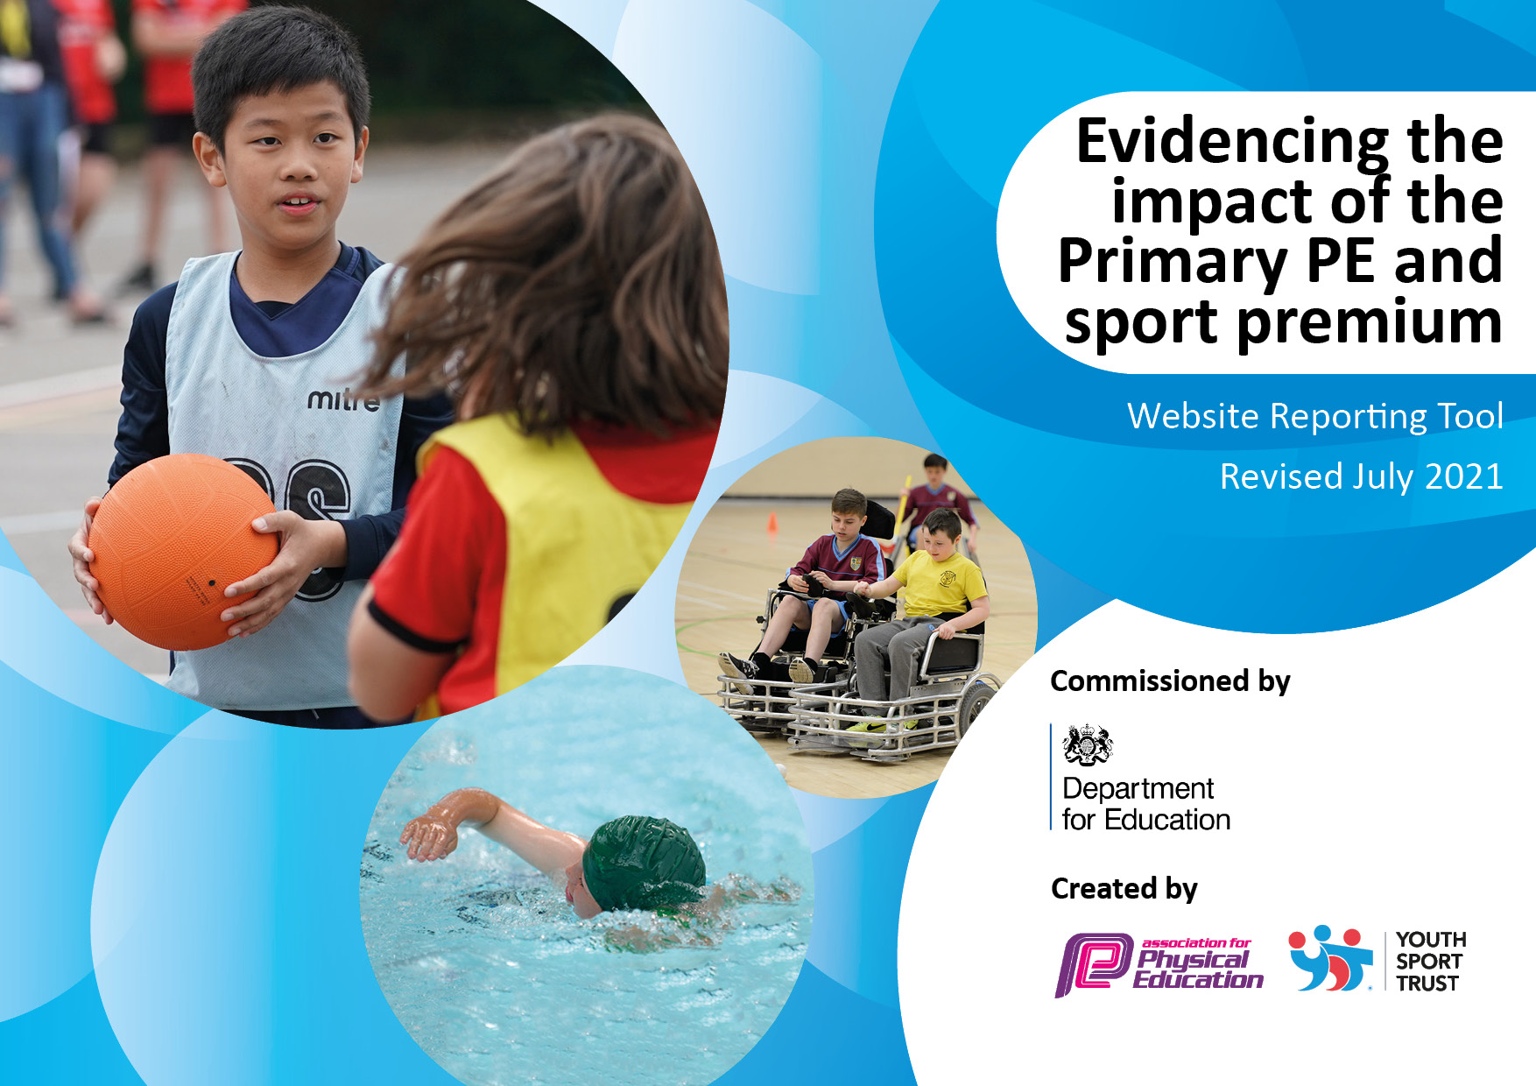

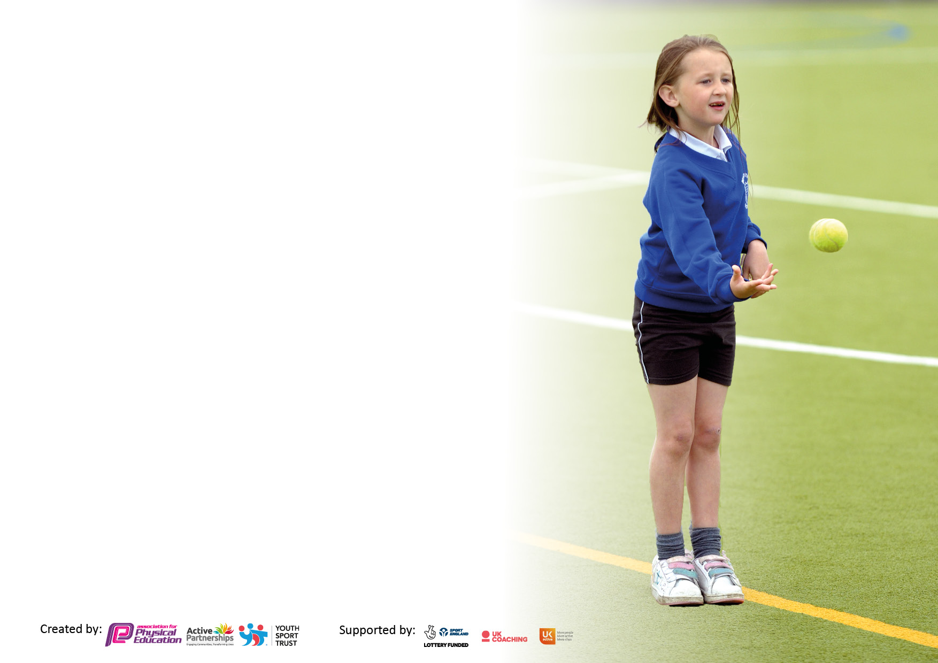

It is important that your grant is used effectively and based on school need. The Education Inspection Framework makes clear there will be a focus on **‘whether leaders and those responsible for governors all understand their respective roles and perform these in a way that enhances the effectiveness of the school’**.

Under the Quality of Education Ofsted inspectors consider:

**Intent** - Curriculum design, coverage and appropriateness

**Implementation** - Curriculum delivery, Teaching (pedagogy) and Assessment

**Impact** - Attainment and progress

To assist schools with common transferable language this template has been developed to utilise the same three headings which should make your plans easily transferable between working documents.

Schools must use the funding to make **additional and sustainable** improvements to the quality of Physical Education, School Sport and Physical Activity (PESSPA) they offer. This means that you should use the Primary PE and sport premium to:

* Develop or add to the PESSPA activities that your school already offer
* Build capacity and capability within the school to ensure that improvements made now will benefit pupils joining the school in future years
* The Primary PE and sport premium should not be used to fund capital spend projects; the school’s budget should fund these.

Pleasevisitgov.ukfortherevisedDfEguidanceincludingthe5keyindicatorsacrosswhichschoolsshoulddemonstrate animprovement.Thisdocumentwillhelpyoutoreviewyourprovisionandtoreportyourspend.DfEencouragesschools to use this template as an effective way of meeting the reporting requirements of the Primary PE and sport premium.

We recommend you start by reflecting on the impact of current provision and reviewing the previous spend.

Schools are required to publish details of how they spend this funding, including any under-spend from 2019/2020, as well as on the impact it has on pupils’ PE and sport participation and attainment. **All funding must be spent by 31st July 2022.**

We recommend regularly updating the table and publishing it on your website throughout the year. This evidences your ongoing self-evaluation of how you are using the funding to secure maximum, sustainable impact. Final copy must be posted on your website by the end of the academic year and no later than the 31st July 2021. To see an example of how to complete the table please click HERE.

Created by: Supported by:

**Details with regard to funding**

Please complete the table below.

|  |  |
| --- | --- |
| Total amount carried over from 2019/20 | £0 |
| Total amount allocated for 2020/21 | £10,181 |
| How much (if any) do you intend to carry over from this total fund into 2021/22? | £10,181 |
| Total amount allocated for 2021/22 | £20,620 |
| Total amount of funding for 2021/22. To be spent and reported on by 31st July 2022. | £30,801 |

**Swimming Data**

Please report on your Swimming Data below.

|  |  |
| --- | --- |
| Meeting national curriculum requirements for swimming and water safety.  N.B. Complete this section to your best ability. For example, you might have practised safe self-rescue techniques on dry land which you can then transfer to the pool when school swimming restarts.  **Due to exceptional circumstances priority should be given to ensuring that pupils can perform safe self-rescue even if they do not fully meet the first two requirements of the NC programme of study** |  |
| What percentage of your current Year 6 cohort swim competently, confidently and proficiently over a distance of at least 25 metres?  **N.B.** Even though your pupils may swim in another year please report on their attainment on leaving primary school at the end of the summer term 2021.  Please see note above | 87% |
| What percentage of your current Year 6 cohort use a range of strokes effectively [for example, front crawl, backstroke and breaststroke]?  Please see note above | 81% |
| **What percentage of your current Year 6 cohort perform safe self-rescue in different water-based situations?** | 99% |
| Schools can choose to use the Primary PE and sport premium to provide additional provision for swimming but this must be for activity **over and above** the national curriculum requirements. Have you used it in this way? | Yes |

**Action Plan and Budget Tracking**

Capture your intended annual spend against the 5 key indicators. Clarify the success criteria and evidence of impact that you intend to measure to evaluate for pupils today and for the future.

|  |  |  |  |  |
| --- | --- | --- | --- | --- |
| **Academic Year:** 2020/21 | **Total fund allocated: £20,620** | **Date Updated:22nd July 2022** | |  |
| **Key indicator 1:** The engagement of all pupils in regular physical activity – Chief Medical Officers guidelines recommend that primary school pupils undertake at least 30 minutes of physical activity a day in school | | | | Percentage of total allocation: |
| % |
| **Intent** | **Implementation** | | **Impact** |  |
| Your school focus should be clear what you want the pupils to know and be able to do and about  what they need to learn and to  consolidate through practice: | Make sure your actions to achieve are linked to your intentions: | Funding allocated: | Evidence of impact: what do pupils now know and what can they now do? What has changed? | Sustainability and suggested next steps: |
| We will provide targeted activities to involve and encourage the least active children to enjoy exercise. We will also establish a comprehensive after school sports clubs and lunchtime activities programme which will be open to all pupils in KS1 and KS2 with equipment purchased which is relevant, appropriate and encourages all pupils to play and be physically active. We will ensure the yards are places which encourage active play. | 1. Lunchtime clubs solely for pupil premium pupils 2. After school clubs offered to all pupils in KS1 and KS2 3. Staff encouraged to use ‘active breaks’ during the school day to increase physical activity levels 4. Equipment purchased to assist delivery of PE, clubs and fixtures (e.g. Yoga mats, volleyballs, cricket tees, netball bibs, cones, stopwatches, netballs, training bibs, equipment carry bags, Carfield flag for cross country) 5. PE lead to regularly visit yards and facilitate active play | Sports Directory UK  £612.74  £153.95  Davies Sports  £335.73  Amazon (netball posts)  £115.98  House of Flags  £180 | 1. 100% of pupil premium pupils in KS1 had access to the lunchtime club 2. Since January 2021, over 100 pupils were attending after school clubs each week across KS1-2 3. Staff pointed towards the GetSet4PE ‘Active Breaks’ and ‘Classroom Activities’ area to use with pupils 4. 100% of pupils who attended clubs will have used relevant equipment for the activity 5. Since September, active play has increased by 30% in KS1 and KS2 yards | We will use more ‘active breaks’ or PAL (physically active learning) within our curriculum across all Key Stages to increase levels of physical activity and promote health and wellbeing.  We will continue to expand and diversify our extra-curricular programme to give opportunities for all pupils to access them.  We will purchase more equipment/resources to continue driving physical activity in PE lessons and at break times in the yards |
| **Key indicator 2:** The profile of PESSPA being raised across the school as a tool for whole school improvement | | | | Percentage of total allocation: |
| % |
| **Intent** | **Implementation** | | **Impact** |  |
| Your school focus should be clear what you want the pupils to know and be able to do and about  what they need to learn and to  consolidate through practice: | Make sure your actions to achieve are linked to your intentions: | Funding allocated: | Evidence of impact: what do pupils now know and what can they now do? What has changed? | Sustainability and suggested next steps: |
| Our PE lead will attend network meetings to develop skills/knowledge to share with staff cohort and pupils. We will also ensure national schemes (including Active Travel Week) to promote healthy and active lifestyles are shared with all stakeholders as frequently as possible with support from the Healthy Schools Team. We will work towards achieving Sportsmark awards, with a focus on developing PESSPA across KS1 and KS2 as well giving Carfield pupils the opportunity to develop leadership skills | 1. Network Meetings and CPD events (Points Learning Network CPD event – Feb 2022, AfPE Teaching Gymnastics Safely, online webinar, March 2022) 2. Leadership opportunities    1. Y5 Sports Leaders    2. Y5 Girls Football Leadership course 3. Active Travel Week    1. Park and Stride    2. ‘Wheely Wednesday’ 4. PESSPA display to be kept up-to-date with relevant information, inspiration and achievements and teaching spaces to feel aspirational and encourage engagement with PESSPA | Points membership  £800  AfPE membership  £217 | 1. PE lead utilised games/practices from the Tennis and Teambuilding sessions with classes back at school (KS1 and lower Key Stage 2 classes)    1. 15 pupils in Y5 were selected to be ‘sports leaders’ in the KS1 yard at morning break and lunchtimes    2. 5 girls in Y5 attended a training day at the EIS to development football leadership 2. Walk and Stride days introduced and scooter and bike days 3. All year groups are represented on the display board with photos from their PE lesson/sports events | Termly, whole school, activities to engage with families, pupils and staff with the focus on improving health and wellbeing. We have already registered and planned for pupils and their families to attempt the TCS Mini London Marathon between 26th September and 21st October 2022  Speak to Carfield Friends to drive participation in the Cat Lane Canter running event during the Spring Term (organised by Carfield Parents)  Buy-in to and develop leadership opportunities across the whole school. Develop strategies to allow all pupils the opportunity to lead, in some capacity, during the year  Development of a ‘Carfield Sports Awards’ evening to celebrate the success of pupils achievements in all areas of PESSPA |

|  |  |  |  |  |
| --- | --- | --- | --- | --- |
| **Key indicator 3:** Increased confidence, knowledge and skills of all staff in teaching PE and sport | | | | Percentage of total allocation: |
| % |
| **Intent** | **Implementation** | | **Impact** |  |
| Your school focus should be clear | Make sure your actions to | Funding | Evidence of impact: what do | Sustainability and suggested |
| what you want the pupils to know | achieve are linked to your | allocated: | pupils now know and what | next steps: |
| and be able to do and about | intentions: |  | can they now do? What has |  |
| what they need to learn and to |  |  | changed? |  |
| consolidate through practice: |  |  |  |  |
| Our class teachers will receive CPD from the PE lead and will be well-supported throughout the academic year in their delivery of PE lessons. Staff will have the opportunity to contribute to the extra-curricular programme and will get access to relevant resources and coaching/teaching materials  All staff will have First Aid qualifications up-to-date so opportunities to take children to sports events are increased  Members of staff are encouraged to attend tournaments/fixtures/festivals to enhance their knowledge of an activity area and improve their confidence in leading teams and/or assisting with large school events (e.g. Sports Day)  Resources will be shared by PE lead and ideas discussed with teachers on a regular basis | 1. PE lead assisted the delivery of PE lessons during the Autumn Term and Spring Term 2. All staff received first aid training (April 2022) 3. Half termly email sent by PE lead with PE planning, suggested activities and location of lesson. Dialogue opened regarding PE support if needed 4. Sports Day events utilised many school staff with a variety of roles and responsibilities. Staff were spoken to before the event to ensure they clearly understood their role on the day. Our KS1 and KS2 Sports Days were a great success | School Merit Stickers  £261  Amazon (Sports Day Shields, Foundation Stage equipment)  £99.80  £18.89 | 1. 66% of staff had access to in-class support from the PE lead 2. Class teachers have led school teams at tournaments/events in the following sports    1. Y6 cricket    2. Y3-4 football    3. Multisport trip to Ponds Forge    4. Indoor Athletics at EIS 3. 3 teachers received further support with PE teaching delivery allowing them to teach the subject with greater confidence 4. Staff were able to confidently teach pupils new skills, record results and organise their activity areas allowing pupils to perform at their best | To identify all staff with an interest in sport/physical activity through a questionnaire and encourage them to uptake CPD to further develop their understanding. Staff to be encouraged and supported in leading extra-curricular clubs  Termly CPD to upskill class teachers and a ‘deep dive’ in PE in the Autumn Term in order to assess where the subject is currently at, and where we wish to take it in the future |
| **Key indicator 4:** Broader experience of a range of sports and activities offered to all pupils | | | | Percentage of total allocation: |
|  |
| **Intent** | **Implementation** | | **Impact** |  |
| Your school focus should be clear | Make sure your actions to | Funding | Evidence of impact: what do | Sustainability and suggested |
| what you want the pupils to know | achieve are linked to your | allocated: | pupils now know and what | next steps: |
| and be able to do and about | intentions: |  | can they now do? What has |  |
| what they need to learn and to |  |  | changed? |  |
| consolidate through practice: |  |  |  |  |
| Pupils will have access to a broad range of activities in curriculum PE and extra-curricular clubs. They will be given opportunities to represent the school in competitions and events and all pupils will be actively encouraged to get involved as much as possible  They will also be given opportunities to represent the school in fixtures/competitions/festivals and therefore access and experience events across the local area. | 1. GetSet4PE platform is used by class teachers and PE teacher to provide pupils with engaging PE lessons  2. Inaugural Sports Day event at the EIS (KS2) and Meersbrook Park (KS1)  3. Extra-curricular clubs – we have implemented a vast array of clubs for pupils across KS1-2 to attend (list below):  - Sheffield Hatters Basketball  - Invictus Gymnastics  - Nature Yoga  - SUFC Community Foundation  - Bradi Lea Dance Company  - The Climbing Works  - Northern Rolling  Class teachers have also organised after school clubs for the below sports:   * Football, dance, cricket, ball skills, badminton and netball   4. Swimming lessons  5. Taster sessions and in-class PE delivery. Pupils in KS1 (Y2) were given taster sessions in the below activities:  - Rugger Eds  Pupils in Y3 were coached by Chance2Shine cricket coaches  6. Mental Health Week – pupils were given taster sessions in the below activities:  - Shaping Healthy Minds Online / Kids Love Yoga  - Boxercise  7. Use of the School Sport Psychology platform to improve pupil wellbeing  8. Coach travel companies were booked to allow us to safely transport teams/pupils to and from fixtures and sports events. We also utilised a car-pooling system, with parent assistance, for many events (especially in Spring 2 and the Summer Term) | £440  £795 - EIS  £75 - Line markings  £0 (clubs paid for by parents through ParentPay)  £3135  Yorkshire Cricket Board  £150  Yoga  £435  School Sport Psychology  £249.99  Beewise Travel  £560  Rivelin Travel  £600  Ashley’s Travel  £1800 | 1. Pupils have experienced activities they may never have tried before. This will have had a positive impact on the pupil's physical literacy  2. Pupils have an improved understanding of how to perform various athletics disciplines. They were also able to perform their skills  3. There was very little extra-curricular provision in 2020-21 and 2021-22 due to COVID-19 restrictions and access to coaches. This year our priority was to give all pupils, the opportunity to try new sports which well-trained sports coaches. Many pupils represented the school in sports that they were able to train for in after school club's settings  a. 42% of pupils in KS2 represented the school in sport on at least one occasion  b. 100% of Y2 pupils represented the school at a sporting event  c. 18% of Y1 pupils represented the school at a sporting event  4. (Statistics can be viewed on Page 3)   1. Pupils were given a voucher for a free Rugger Eds session at the weekend which 8 pupils (12%) of the year group took up 2. 75% of pupils (Y3-5) said they enjoyed the yoga session and would like to do it again 3. 12 pupils in KS2 had access to the School Sport Psychology platform, promoting life skills and techniques from the world of sport psychology 4. 290 pupils across KS1-2 were able to travel to a sports event via hired transport and represent the school | Continue to monitor the use of this platform. If the content remains relevant, challenging and engaging for pupils then we will renew  Develop our Sports Day programme to encourage other activities to be pursued in the future  To embed good practice and range of sports clubs to cover wider activity areas. Also, look into introducing ‘girls only’ clubs in order to focus on attaining the ‘Active Girls Award’ at the Sheffield Schools Get Active Awards 2023  To support swimming provision by providing training to class teachers and offering pupils the chance to improve their knowledge or ‘water safety’ through classroom delivery of content  Aim to increase the use of the school sport psychology platform to help foster greater self-esteem and confidence in our pupils  To utilise public transport and parent car-pooling systems to make travelling to and from competitions more cost-effective |

|  |  |  |  |  |
| --- | --- | --- | --- | --- |
| **Key indicator 5:** Increased participation in competitive sport | | | | Percentage of total allocation: |
| % |
| **Intent** | **Implementation** | | **Impact** |  |
| Your school focus should be clear | Make sure your actions to | Funding | Evidence of impact: what do | Sustainability and suggested |
| what you want the pupils to know | achieve are linked to your | allocated: | pupils now know and what | next steps: |
| and be able to do and about | intentions: |  | can they now do? What has |  |
| what they need to learn and to |  |  | changed? |  |
| consolidate through practice: |  |  |  |  |
| Pupils have had the opportunity to represent the school in many sports this year. When possible, we have tried to give the widest range of pupils the chance to participate, and have encouraged those who may not choose sports naturally, the opportunity to give it a go.  All pupils in KS2 will have the opportunity to compete on an intraschool basis at our annual Sports Day. | In order to access a range of competitive opportunities we signed up with the below organisations for the academic year 2021-22:   1. SFSS (Sheffield Federation of Schools Sports) competitions 2. Points Learning Network events 3. School Games events 4. Sheffield United Community Programme 5. Schools' bouldering competition   KS2 Sports Day at the English Institute of Sport arranged to allow for:   * Individual competition * Class competitions (by year group) | SFSS  £100  The Climbing Works  £60 | 1. Our pupils were very successful in the SFSS Cross Country competition. We regularly had large number of pupils participating and they developed a strong sense of team spirit, pride in their school, and self-determination.  * 79 runners (Y3-6) represented the school on at least one occasion * 6th place and 8th place finishers in the Y3-4 boys Cross Country League event * Y3-4 Girls Team finished in 5th place overall * Y3-4 Boys Team finished in 6th place overall * 4th place finish for a Y4 boy runner in the Primary Championships @ Graves * Y3-4 Boys Team finished in 3rd place in the Primary Championships @ Graves   Our pupils also finished 1st in League C in the Y5-6 Netball Competition but were unfortunately unable to attend the Sheffield finals as this date clashed with the Y6 Residential   1. Pupils attended:    1. KS2 boys' and girls' football and futsal    2. KS1 Santa Run    3. KS2 netball 2. Pupils attended:    1. KS2 Sports Showcase (pupil premium pupils)    2. KS2 Indoor Athletics 3. EFL Kids Cup for KS2 4. Our Y5-6 team did tremendously well and finished 3rd in the Sheffield finals   -164 medals were presented to pupils who finished in 1st, 2nd, 3rd in their individual events or relays  - Podium used to allow pupils to enjoy and celebrate their success  - 39 out of 120 individual medals were presented to girls (33%) whilst 81 (67%) were presented to boys | We have continued our membership to SSFS and will look to access further competitions next academic year (Primary Athletics, Orienteering)  We are also aiming to achieve Gold in the KS1 and KS2 Sportsmark award which will involve increasing opportunities for competition  Continuation of our climbing club to aim at improving our climbing team further  Adjustments made to Sports Day programme to give greater opportunities for girl's success  To develop further opportunities for intraschool competition throughout the school year |

|  |  |
| --- | --- |
| Signed off by Hannan Mohammed | |
| Head Teacher: |  |
| Date: | 25th July 2022 |
| Subject Leader: | Tom Arnold |
| Date: | 25th July 2022 |
| Governor: |  |
| Date: |  |